**ACKNOWLEDGEMENT**

Any achievement does not depend solely on individual efforts but the guidance, encouragement, and cooperation of intellectuals, elders, and friends. Some personalities, in their capacities, have helped us in carrying out this project work. We would like to take this opportunity to thank them all.

First, we would like to thank Prof. Abhishek Deshmukh, our project guide. We thank him a lot for the guidance and cooperation, which he has provided throughout the journey.

We would like to convey our heartfelt thanks to projecting coordinator Prof. Vaidehi Deshpande and Dr. Sujata N B, Head of the Department Dr. Supriya Shanbhag, and Principal for allowing us to work on this topic.

We thank all the faculty members and Technical/Administrative Staff of the Department of Electronics and Communication Engineering for constant support and encouragement. We would also like to thank each one of those who have helped us in this endeavour.

Last, but not least, we would like to thank our parents and friends who provided us with valuable suggestions to improve our project.

Nayana Naganoor

Nishat Fatima Punekar

Sachin Barker

Sammed Chougule

**ABSTRACT**

The growing demand for sustainable and efficient energy solutions in electric vehicles (EVs) has highlighted the need for optimized battery systems that balance performance, cost, and longevity. This project explores the design and implementation of a hybrid battery system combining lithium-ion and lead-acid batteries. The lithium-ion battery serves as the primary energy source for propulsion, offering high energy density and rapid charge/discharge capabilities, while the lead-acid battery is utilized for auxiliary applications, such as lighting and dashboard functions, due to its cost-effectiveness and durability.

The hybrid system design incorporates a power management mechanism to segregate loads between the two battery types, ensuring efficient energy utilization and extended lifespan of the batteries. Simulations conducted in MATLAB/Simulink provided in-depth analyses of the batteries’ state of charge (SOC), voltage response, thermal behavior, and overall system efficiency. Key findings include:

Lithium-Ion Battery Performance: Exhibited stable voltage and current profiles under varying propulsion loads, with extended endurance in scenarios where auxiliary loads were excluded.

Lead-Acid Battery Contribution: Demonstrated reliability in handling auxiliary loads with minimal SOC depletion, reducing the burden on the lithium-ion battery and improving overall system efficiency.

Hybrid System Efficiency: Effective load segregation and seamless switching between the two batteries enabled optimized power distribution, preventing overloading and improving energy utilization.

The results validated the hybrid system's capability to meet the diverse power demands of EVs while reducing dependency on expensive lithium-ion batteries. Additionally, the simulations highlighted the thermal stability and degradation characteristics of the batteries, providing insights into practical design considerations.

This study presents a cost-effective and sustainable approach to hybrid battery systems for EV applications, emphasizing the importance of energy management and system reliability. Future work includes scaling the system for larger EV platforms, and integrating additional energy sources such as supercapacitors or renewable energy systems. The findings contribute significantly to the development of next-generation EV battery architectures, promoting affordability and environmental sustainability.

|  |  |  |  |
| --- | --- | --- | --- |
|  |  |  |  |
|  |  |  |  |
|  |  |  |  |
|  |  |  |  |
|  |  |  |  |
|  |  |  | vii |
|  |  |  |  |
|  |  |  |  |
|  |  |  | 5 |
|  |  |  | 7 |
|  |  |  | 17 |
|  |  |  | 25 |
|  |  |  | 25 |
|  |  |  | 25 |
|  |  |  | 25 |
|  |  |  | 35 |
|  |  |  | 35 |
|  |  |  | 37 |
|  |  |  | 39 |
|  |  |  | 39 |
|  |  |  | 39 |
|  |  | References | 40 |

|  |  |  |
| --- | --- | --- |
| **Figure No.** | **Title** | **Page No.** |
| 4.1 | Simscape Simulation Model of Li-ion Battery | 26 |
| 4.2 | Simulation Results of Li-ion Battery | 26 |
| 4.3 | Simscape Simulation Model of Lead Acid Battery | 28 |
| 4.4 | Simulation Results of Lead Acid Battery | 28 |
| 4.5 | Simscape Simulation Model of Nickel Metal Hydride  Battery | 30 |
| 4.6 | Simulation Results of Nickel Metal Hydride Battery | 30 |
| 4.7 | Simscape Simulation Model of Hybrid Battery System  without Auxillary Load | 32 |
| 4.8 | Simscape Simulation Model of Hybrid Battery System  with Auxillary Load | 32 |

**CHAPTER 1**

**INTRODUCTION**

* 1. **Introduction**

This chapter provides a comprehensive overview of the research into hybridizing lithium-ion and lead-acid batteries for electric vehicles (EVs). With the rising global demand for efficient, cost-effective, and environmentally sustainable energy storage solutions, hybrid battery systems represent an innovative step forward. By combining the strengths of lithium-ion and lead-acid technologies, this research seeks to address the limitations of each when used as standalone systems. The discussion explores key factors influencing hybrid battery performance, challenges, and their potential to revolutionize EV energy storage.

**1.1.1 Lithium-Ion Batteries**

Lithium-ion batteries are integral to modern energy storage, particularly in electric vehicles, due to their high energy density, lightweight construction, and efficiency. These qualities enable EVs to achieve extended driving ranges while supporting rapid charging and minimal energy loss. Their operation relies on the movement of lithium ions between the anode and cathode, allowing for high cycle life and durability. Advancements like solid-state electrolytes and improved anode materials are driving innovations that promise greater safety and performance.

However, challenges persist, including high production costs driven by rare materials like lithium and cobalt, which also raise environmental and ethical concerns. Lithium-ion batteries are temperature-sensitive, with performance degradation in extreme heat or cold, necessitating advanced thermal management systems. Safety risks, such as thermal runaway, require robust battery management systems to mitigate hazards. Furthermore, the environmental impact of production and limited recycling infrastructure poses sustainability challenges.

Despite these drawbacks, lithium-ion technology remains pivotal in the shift to cleaner energy. Efforts to develop cost-effective, sustainable solutions, including recycling initiatives and hybrid systems, aim to address these limitations. Hybridization, in particular, offers an opportunity to combine the strengths of lithium-ion batteries with complementary technologies to overcome their constraints, improving overall affordability, efficiency, and environmental impact.

**1.1.2 Lead-Acid Batteries**

Lead-acid batteries, one of the oldest and most established energy storage technologies, remain highly relevant due to their simplicity, robustness, and affordability. They have been extensively used in automotive applications, especially for starting engines, and in backup power systems for critical infrastructure. Their ability to deliver high surge currents makes them ideal for applications requiring significant peak power. This characteristic, coupled with their straightforward design and mature manufacturing processes, has enabled lead-acid batteries to maintain a prominent position in the energy storage market for decades.

A major advantage of lead-acid batteries is their recyclability, with a recovery rate exceeding 95%, setting a gold standard for sustainable practices in energy storage. Their widespread recycling infrastructure minimizes environmental impact and reduces the need for raw material extraction, making them a model for other battery technologies. However, their limitations are notable. The low energy density and substantial weight of lead-acid batteries hinder their practicality in long-range electric vehicles, where lightweight and high-capacity energy solutions are critical. Frequent deep cycling accelerates capacity loss, shortening their lifespan and necessitating regular replacement in demanding applications.

Despite their drawbacks, lead-acid batteries remain valuable in hybrid systems due to their cost-effectiveness and reliability. When integrated with lithium-ion batteries, they can address specific energy storage challenges by managing peak power demands and stabilizing the system. Hybridization leverages the strengths of lead-acid batteries while compensating for their weaknesses, making them a complementary technology in the pursuit of efficient, affordable, and sustainable energy solutions for electric vehicles and other applications.

**1.1.3 Hybridization Concept**

The concept of hybridization in energy storage merges the best attributes of lithium-ion and lead-acid batteries to address the diverse demands of electric vehicles (EVs). Lithium-ion batteries contribute their high energy density and efficiency, making them ideal for supporting long-range driving and sustained energy storage. Meanwhile, lead-acid batteries provide cost-effective solutions for high power delivery, such as during acceleration and peak load conditions. This complementary integration ensures that each battery type performs tasks aligned with its strengths, optimizing the overall energy management system.

Advanced power management systems form the core of hybridized battery operation, dynamically allocating energy tasks to maximize performance. During steady cruising, lithium-ion batteries handle prolonged energy supply efficiently. In contrast, lead-acid batteries excel at providing the sudden bursts of power required for acceleration. Additionally, the hybrid system captures and stores energy from regenerative braking, a feature critical for improving overall efficiency and minimizing energy waste. By leveraging the distinct capabilities of each battery, hybrid systems enhance functionality and durability.

This hybrid approach addresses the pressing need for balance in EV energy storage systems, blending performance, reliability, and cost-effectiveness. By minimizing the limitations of each battery type, hybridization provides a sustainable and innovative pathway for improving EV adoption. It not only enhances energy efficiency and system longevity but also reduces costs, making EV technology more accessible to a broader market while meeting environmental and performance objectives.

**1.1.4 Advantages of Hybridization**

The hybridization of lithium-ion and lead-acid batteries offers several compelling advantages. One significant benefit is the ability to achieve optimized performance by combining the energy storage capabilities of lithium-ion batteries with the power delivery characteristics of lead-acid systems. This results in a more efficient and versatile energy storage solution. Additionally, hybrid systems reduce the reliance on expensive lithium-ion components, making them more cost-effective. They also improve durability and resilience, as the load is shared between the two battery types, mitigating wear and tear on individual components. This synergy enhances the overall sustainability and practicality of EVs.

**1.1.5 Technological Integration**

The integration of lithium-ion and lead-acid batteries in a hybrid system requires advanced technological solutions. Power management systems play a pivotal role in regulating energy flow and ensuring the optimal use of both batteries. This involves the development of sophisticated algorithms and controllers capable of real-time monitoring and decision-making. Furthermore, thermal management systems are critical to maintaining temperature stability and preventing overheating, especially during high-demand scenarios. Effective integration also necessitates the use of converters and interface devices to address voltage mismatches and ensure seamless compatibility between the two battery types.

**1.1.6 Environmental Implications**

Hybrid battery systems hold significant environmental potential by addressing some of the ecological concerns associated with standalone technologies. The reduced dependence on lithium and cobalt helps mitigate the adverse effects of mining activities, including habitat destruction and resource depletion. Lead-acid batteries’ high recyclability further supports sustainability, ensuring that valuable materials are recovered and reused. By improving the efficiency and lifespan of energy storage systems, hybridization contributes to lowering the overall environmental footprint of EV production and operation. This aligns with global efforts to combat climate change and promote green mobility solutions.

**1.1.7 Challenges in Implementation**

Despite their advantages, hybrid battery systems face notable challenges in their implementation. One major hurdle is the complexity of developing control systems capable of balancing the differing characteristics of lithium-ion and lead-acid batteries. Ensuring compatibility in terms of voltage, thermal behavior, and lifecycle characteristics requires innovative engineering approaches. Thermal management systems must also be carefully designed to handle the combined heat output of hybrid systems. Additionally, the initial cost of developing and deploying hybrid technologies may be prohibitive, necessitating further research to optimize manufacturing processes and achieve economies of scale.

**1.1.8 Objectives**

The primary objectives of this research are to:

* Conduct an in-depth analysis of the performance characteristics of lithium-ion and lead-acid batteries under varying operational conditions.
* Design and propose an integrated hybrid battery architecture tailored for electric vehicles.
* Develop and validate a power management strategy for efficient operation of hybrid systems.
* Assess the economic feasibility and environmental impact of hybrid battery systems compared to standalone alternatives.
* Perform comparative studies to evaluate the practical applicability and benefits of hybridization in real-world EV scenarios.
* Explore potential advancements in hybrid battery technologies to enhance EV adoption rates.

**1.1.9 Future Trends and Opportunities**

The future of hybrid battery systems is bright, with ongoing research and development aimed at enhancing their performance and affordability. Emerging trends include the use of machine learning and artificial intelligence to develop smarter power management systems, capable of adaptive decision-making and predictive maintenance. Advancements in materials science are also expected to improve the energy density and durability of both lithium-ion and lead-acid batteries, further optimizing hybrid systems. Additionally, the growing emphasis on circular economies presents opportunities to improve recycling processes and material recovery, ensuring the sustainability of hybrid battery technologies. As the EV market expands, hybrid systems are poised to play a pivotal role in meeting the diverse energy storage needs of future vehicles.

**Summary**

This chapter has provided an introduction to the key aspects of lithium-ion and lead-acid batteries, emphasizing their individual advantages and limitations. It has outlined the hybridization concept as a promising solution for improving EV energy storage systems. By addressing the outlined challenges and meeting the research objectives, this study aims to significantly advance the development of sustainable, efficient energy storage technologies for electric vehicles. The subsequent chapters will delve deeper into the literature review, experimental methodologies, and analytical findings to explore hybrid battery systems comprehensively.

# **CHAPTER 2 LITERATURE REVIEW AND RESEARCH GAP**

**1. Name: "Experimental Investigations into a Hybrid Energy Storage System Using Directly Connected Lead-Acid and Li-Ion Batteries", 2024**

This paper explores the integration of lead-acid and lithium-ion batteries in a hybrid energy storage system. The study focuses on the design, implementation, and performance evaluation of this system, aiming to combine the advantages of both battery types to enhance overall efficiency and reliability.

**Key Areas of Investigation:**

* **System Design and Configuration:** The article details the architecture of the hybrid energy storage system, including the direct connection methodology between lead-acid and lithium-ion batteries. It examines the electrical and mechanical integration processes to ensure optimal performance.
* **Performance Evaluation:** Through experimental investigations, the study assesses the system's performance under various operational conditions. Metrics such as charge/discharge efficiency, energy density, and cycle life are analyzed to determine the effectiveness of the hybrid configuration.
* **Advantages of Hybridization:** The research highlights how combining lead-acid and lithium-ion batteries can leverage the high power density of lithium-ion with the cost-effectiveness and robustness of lead-acid batteries. This synergy aims to improve the overall performance and lifespan of the energy storage system.

**Research Gap:**

While the study provides valuable insights into the hybrid energy storage system, several areas require further exploration:

* **Long-Term Durability:** Extended testing is necessary to evaluate the long-term durability and reliability of the hybrid system, particularly concerning the aging characteristics of both battery types when used in conjunction.
* **Optimal Control Strategies:** Developing advanced control algorithms to manage the charge and discharge cycles between the two battery types is crucial. Such strategies would ensure balanced usage, prevent overcharging or deep discharging, and enhance system efficiency.
* **Economic Analysis:** A comprehensive cost-benefit analysis considering the initial investment, maintenance costs, and potential savings from improved efficiency would provide a clearer understanding of the economic viability of the hybrid system.

Addressing these research gaps is essential for advancing hybrid energy storage technologies. By focusing on long-term performance, control optimization, and economic feasibility, future research can contribute to the development of more efficient and reliable energy storage solutions, facilitating the integration of renewable energy sources and enhancing grid stability.

**2. Name: Design and control of the hybrid lithium-ion/lead–acid batter by Sebastian Wodyk , Maciej Wieczorek , Paweł Witaszek , Rafał Poliszkiewicz, 2023**

The article *"A comprehensive review on hybrid energy storage systems: Architectures, control strategies, and future directions"* provides an in-depth analysis of hybrid energy storage systems (HESS). The study focuses on the design, implementation, and evaluation of various HESS configurations, aiming to optimize performance, reliability, and cost-effectiveness by combining the strengths of multiple energy storage technologies.

**Key Areas of Investigation:**

* **HESS Architectures:**The article examines different configurations of hybrid energy storage systems, including parallel, series, and mixed architectures. It discusses how these configurations integrate diverse energy storage technologies to achieve improved performance and efficiency.
* **Control Strategies:**The study explores advanced energy management systems and control mechanisms, such as model predictive control and real-time optimization. These strategies aim to balance energy flow and extend the lifecycle of system components.
* **Applications and Performance Evaluation:**

The research highlights the application of HESS in sectors such as renewable energy integration, electric vehicles, and grid stabilization. Metrics such as energy density, power delivery, and lifecycle performance are analyzed to assess the effectiveness of HESS in real-world scenarios.

**Research Gap:**

While the study provides comprehensive insights into hybrid energy storage systems, several areas require further exploration:

* **Long-Term Durability:**Extended testing is needed to evaluate the durability and reliability of HESS, focusing on the aging characteristics of individual components in mixed configurations.
* **Advanced Control Strategies:**Developing more sophisticated algorithms to manage energy flow dynamically and handle unpredictable load patterns effectively is essential for improving system efficiency.
* **Economic Analysis:**Detailed cost-benefit analyses, including capital costs, operational savings, and maintenance expenses, are crucial to assess the economic feasibility of deploying HESS on a large scale.

Addressing these research gaps is critical for the advancement of hybrid energy storage technologies. By focusing on long-term performance, control optimization, and economic feasibility, future research can contribute to the development of efficient and reliable energy storage solutions, supporting the integration of renewable energy sources and ensuring grid stability.

**3. Name: A Battery Management Strategy in a Lead-Acid and Lithium-Ion Hybrid Battery Energy Storage System for Conventional Transport Vehicles by Andre T. Puati Zau., 2022**

This paper *"A Battery Management Strategy in a Lead-Acid and Lithium-Ion Hybrid Battery Energy Storage System for Conventional Transport Vehicles"* investigates the development of a battery management strategy (BMS) for hybrid energy storage systems (HESS) combining lead-acid and lithium-ion batteries. The study aims to enhance energy efficiency, extend battery lifespan, and improve the overall reliability of conventional transport vehicles.

Key Areas of Investigation:

* **Battery Management System Design:**The article details the architecture of the battery management strategy, focusing on the integration of lead-acid and lithium-ion batteries. It examines methodologies for efficient energy distribution and optimal usage of both battery types.
* **Performance Optimization:**  
  Through simulations and experiments, the study evaluates the performance of the proposed BMS under various operating conditions. Metrics such as energy efficiency, charge/discharge cycles, and system stability are analyzed.
* **Advantages of Hybrid Energy Storage:**  
  The research highlights the complementary benefits of using lead-acid and lithium-ion batteries, leveraging the high power density and rapid response of lithium-ion with the cost-effectiveness and robustness of lead-acid batteries to meet the energy demands of transport vehicles.

**Research Gap:**

While the study offers valuable insights into the battery management strategy for hybrid systems, several areas require further exploration:

* Long-Term Durability: Extended testing is necessary to assess the long-term reliability of the hybrid battery system, particularly in demanding operational environments such as transport applications.
* Advanced Control Algorithms: The development of more sophisticated control strategies to balance the state of charge (SOC) between lead-acid and lithium-ion batteries is crucial. This includes addressing issues such as overcharging, deep discharging, and thermal management.
* Economic Feasibility: A comprehensive cost analysis, including installation, maintenance, and potential energy savings, is needed to evaluate the viability of implementing the proposed BMS in conventional transport vehicles.

Addressing these research gaps is essential for advancing hybrid battery energy storage technologies. By focusing on durability, control optimization, and economic evaluation, future research can contribute to the development of efficient, reliable, and cost-effective energy storage solutions for transport applications.

**4. Name: Techno-economic analysis of lithium-ion and lead-acid batteries in stationary energy storage application by Abraham Alem Kebede , Thierry Coosemans , Maarten Messagie , Towfik Jemal , Henok Ayele Behabtu , Joeri Van Mierlo , Maitane Berecibar, 2021**

Key Areas of Investigation

* **System Architecture:** The study presents a comprehensive design of the battery management system, focusing on the integration of lead-acid and lithium-ion batteries within a single energy storage framework. This hybrid configuration aims to optimize the performance of transport vehicles by combining the high energy density and rapid response of lithium-ion batteries with the cost-effectiveness, robustness, and high capacity of lead-acid batteries.
* **Integration Methodology:** It explores the challenges associated with directly connecting batteries of different chemistries, emphasizing the need to manage their differing voltage levels, charge/discharge rates, and thermal behaviors. The research proposes methodologies for seamless electrical and mechanical integration while ensuring compatibility and safety.
* **Operational Strategies:** The BMS is designed to monitor and control key parameters such as state of charge (SOC), depth of discharge (DOD), and temperature. These operational strategies aim to balance energy distribution effectively between the two battery types, reducing the strain on individual components and extending their lifespan.
* **Experimental Analysis:** The study evaluates the performance of the hybrid energy storage system through a series of experimental investigations under varying operational conditions. These tests measure metrics such as charge/discharge efficiency, energy density, power output, and thermal stability.
* **Performance Metrics:** The research identifies key performance indicators, including improved energy utilization, enhanced cycle life, and faster response times.

**Research Gap**

* **Long-Term Durability**

The study primarily focuses on short-term performance metrics, leaving a gap in understanding the long-term durability of the hybrid energy storage system. Further research is required to evaluate the aging characteristics and degradation patterns of both lead-acid and lithium-ion batteries when used in hybrid configurations over extended periods.

* **Advanced Control Algorithms**

While the current BMS provides a functional framework, the development of more sophisticated control algorithms is essential. Advanced strategies, such as AI-driven or machine-learning-based algorithms, could dynamically adapt to changing load requirements, manage the SOC more effectively, and address issues like thermal runaway and component overuse.

* **Economic Feasibility**

The study lacks a detailed cost-benefit analysis that includes the initial investment, operational savings, maintenance expenses, and lifecycle costs. Such an analysis is critical to determine the economic viability of deploying the hybrid system in conventional transport vehicles at scale.

* **Scalability**

While the system is tailored for transport applications, further research is needed to explore its scalability for larger applications, such as heavy-duty vehicles or grid energy storage. Addressing scalability challenges will be key to broadening the system's applicability.

* **Environmental Impact**

The environmental implications of manufacturing, operating, and recycling hybrid systems are not thoroughly addressed. Future studies should focus on the lifecycle environmental impact, including the sourcing of materials, energy consumption, and waste management.

**5. Name: A comparative study of lithium ion to lead acid batteries for use in UPS applications by** [**Ana-Irina Stan**](https://www.researchgate.net/profile/Ana-Irina-Stan?_tp=eyJjb250ZXh0Ijp7ImZpcnN0UGFnZSI6InB1YmxpY2F0aW9uIiwicGFnZSI6InB1YmxpY2F0aW9uIn19) **,**[**Maciej Swierczynski**](https://www.researchgate.net/scientific-contributions/Maciej-Swierczynski-55908851?_tp=eyJjb250ZXh0Ijp7ImZpcnN0UGFnZSI6InB1YmxpY2F0aW9uIiwicGFnZSI6InB1YmxpY2F0aW9uIn19),[**Daniel-Ioan Stroe**](https://www.researchgate.net/profile/Daniel-Ioan-Stroe),[**Remus Teodorescu**](https://www.researchgate.net/profile/Remus-Teodorescu?_tp=eyJjb250ZXh0Ijp7ImZpcnN0UGFnZSI6InB1YmxpY2F0aW9uIiwicGFnZSI6InB1YmxpY2F0aW9uIn19)**, 2014**

Key Areas of Investigation

* **Valve-Regulated Lead-Acid (VRLA) Batteries:** VRLA batteries are the most commonly used in Uninterruptible Power Supply (UPS) systems due to their sealed design, affordability, and maintenance-free operation. The study delves into their performance limitations, such as lower energy density, limited cycle life, and sensitivity to temperature variations. These factors often result in higher replacement frequency and lower overall efficiency in demanding applications.
* **Lithium Iron Phosphate (LFP) Batteries:** LFP batteries, a type of lithium-ion chemistry, are examined for their high thermal stability and safety. The study highlights their long cycle life, consistent performance across a range of temperatures, and better energy density compared to VRLA. These attributes make LFP batteries suitable for compact and reliable UPS systems in high-demand settings.
* **Lithium Titanate Oxide (LTO) Batteries:** LTO batteries are evaluated for their unique characteristics, such as exceptional charge/discharge rates, unparalleled cycle life, and robust thermal stability. While these batteries are costlier, their ability to withstand deep discharges and rapid charging scenarios positions them as a cutting-edge alternative for UPS applications requiring frequent power cycling.
* Energy Density: The energy density of the batteries, both gravimetric (per unit weight) and volumetric (per unit volume), is compared. The study emphasizes the advantage of lithium-ion batteries, particularly LFP and LTO chemistries, in enabling more compact and lightweight UPS designs without compromising power delivery.
* Cycle Life and Durability: Lithium-ion batteries, especially LTO, are shown to significantly outperform VRLA batteries in terms of cycle life. The study quantifies the expected number of charge/discharge cycles before noticeable degradation occurs, demonstrating the reduced maintenance and replacement needs of lithium-ion options.

**Research Gaps**

**Cost Analysis:** While Li-ion batteries offer numerous technical advantages, their higher initial costs compared to VRLA batteries are a significant consideration. A comprehensive cost-benefit analysis, including total cost of ownership over the system's lifespan, is necessary to determine economic feasibility.

**Compatibility with Existing UPS Infrastructure:** The integration of Li-ion batteries into existing UPS systems may require modifications to charging algorithms, housing, and thermal management systems. Research into seamless integration strategies is essential to facilitate adoption.

**Long-Term Reliability Data:** Although Li-ion batteries demonstrate promising cycle life in controlled environments, real-world long-term reliability data, especially under varied load and environmental conditions typical of UPS applications, are limited. Extended field studies are needed to validate laboratory findings.

**Environmental and Recycling Considerations:** The environmental impact of Li-ion batteries, including resource extraction, manufacturing processes, and end-of-life recycling, requires thorough investigation to ensure sustainable deployment in UPS systems.

**6. Name: "Hybridization of Batteries for Sustainable EV Development," C. Lee and H. Kim, 2021.**

This paper examines the sustainability implications of hybrid battery systems, with a particular focus on resource efficiency and the recyclability of lithium-ion and lead-acid batteries. Hybrid systems are often considered more sustainable than traditional battery technologies because they can reduce the demand for scarce and expensive materials, such as lithium and cobalt, while maintaining acceptable levels of performance. The study highlights the potential for hybridization to reduce the overall environmental footprint of energy storage systems in electric vehicles. By combining the strengths of lithium-ion and lead-acid batteries, these systems can offer cost-effective, energy-efficient, and environmentally friendly solutions for EV energy storage. The paper also looks at how hybrid systems can help reduce the environmental impact of battery manufacturing and improve the recyclability of used batteries.

Research Gap:

Although the sustainability aspects are thoroughly discussed, the paper lacks a detailed exploration of the operational challenges faced by hybrid battery systems in terms of charge balancing, power distribution, and energy management. These factors are critical for ensuring the reliable and efficient operation of hybrid systems. Future research could focus on developing advanced power management algorithms that optimize the interaction between different battery chemistries, ensuring that energy is distributed efficiently and minimizing the risk of overcharging or undercharging.

**7. Name: "Optimizing Power Distribution in Hybrid Energy Storage," D. Wang et al., 2022.**

This paper introduces an optimization framework designed to improve power distribution in hybrid lithium-ion and lead-acid battery systems. The study uses machine learning algorithms to enhance the energy efficiency of hybrid systems by reducing energy losses during high-demand driving scenarios, such as acceleration or uphill driving. By continuously monitoring the energy usage and state of charge of both battery types, the system can intelligently manage the power flow to minimize energy wastage and ensure optimal performance. The study demonstrates how machine learning techniques can be used to make real-time adjustments to the power distribution, ensuring that the hybrid system operates at peak efficiency during various driving conditions. The optimization framework helps extend the lifespan of both battery types while improving the overall performance of the hybrid system.

**Research Gap:**

Although the paper presents a promising optimization framework, it does not fully explore the challenges associated with the computational complexity of real-time machine learning algorithms. In practice, the algorithms must operate within tight time constraints, making it essential to develop lightweight, computationally efficient models that can run on embedded systems without excessive processing power. Future research could explore the scalability and computational efficiency of these algorithms, focusing on real-time solutions that are practical for deployment in electric vehicles.

**8. Name: "Economic Feasibility of Hybrid Battery Systems," P. Singh and A. Kumar, 2022.**

This research investigates the economic feasibility of hybrid battery systems for electric vehicles by analyzing various factors, such as production costs, operational expenses, and lifecycle savings. The study compares the overall cost of ownership between hybrid and standalone battery systems, highlighting how hybridization can lead to substantial cost reductions without compromising vehicle performance. By using lead-acid batteries for specific tasks like peak load management, the hybrid system reduces the overall cost of energy storage, making EVs more affordable for consumers. The paper also provides a comparative analysis of the lifecycle savings, considering the reduced need for battery replacements and the potential for extended battery life.

**Research Gap:**

The paper does not take into account the potential impact of government policies, subsidies, or incentives on the adoption of hybrid battery systems. Policies such as tax incentives, emission regulations, and subsidies for clean energy technologies can significantly affect the economic feasibility of hybrid systems. Future research could investigate how these regulatory frameworks influence the adoption rate of hybrid battery systems in the EV market, as well as the potential for government intervention to promote the development of sustainable and cost-effective hybrid technologies.

# **CHAPTER 3** **IPR PRIOR ART SEARCH**

A prior art search is an essential step in any project report to determine the novelty and inventiveness of an idea or invention. This search involves investigating existing patents, scientific literature, and other publicly available resources to find prior disclosures related to the project topic. The purpose is to identify prior art existing knowledge and inventions that may invalidate or limit the novelty of the project's concept. By conducting a thorough prior art search, researchers can assess the potential for patentability, identify gaps in existing knowledge, and gain insights for further development. This process ensures that the project report acknowledges the existing body of knowledge, demonstrates innovation, and adds value to the field of study.

**1. IPR 1:  Battery state of charge estimation system for a hybrid/electric vehicle**

Patent number: 20210237614

Application Number: 16781346

Applicant name: FORD GLOBAL TECHNOLOGIES, LLC

Country: United States of America

Inventor name: Yixin Yao

Xiaohong Duan

Mark Steven Yamazaki

Richard Dyche Anderson

Publication Date: 05.08.2021

Abstract: A vehicle includes a battery, an electric machine, and a controller. The battery has a state of charge. The electric machine is configured to draw electrical power from the battery to propel the vehicle in response to an acceleration request and to deliver electrical power to the battery to recharge the battery. The controller is programmed to adjust an estimation of battery state of charge based on a feed forward control that includes a coulomb counting algorithm, a first feedback control that includes a first battery model, and a second feedback control that includes a second battery model. The controller is further programmed to control the electrical power flow between the battery and the electric machine based on the estimation of the state of charge of the battery.

**Claims:**

1. A vehicle comprising a battery having a state of charge an electric machine configured to draw electrical power from the battery to propel the vehicle in response to an acceleration request and to deliver electrical power to the battery to recharge the battery; and a controller programmed to, adjust an estimation of the battery state of charge based on a feed forward control, wherein the feed forward control includes a coulomb counting algorithm that adjusts the estimation of the state of charge of the battery based on a measured current flowing in and out of the battery, adjust the estimation of the battery state of charge based on a first feedback control that includes a first battery model that outputs a first estimated voltage of the battery based on a current state of charge of the battery, wherein the first feedback control adjusts the estimation of the battery state of charge based on a difference between a measured voltage of the battery and the first estimated voltage of the battery, adjust the estimation of the battery state of charge based on a second feedback control that includes a second battery model that outputs a second estimated voltage of the battery based on the current state of charge of the battery, a temperature of the battery, and the measured current flowing in and out of the battery, wherein the second feedback control adjusts the estimation of the battery state of charge based on a difference between the first estimated voltage of the battery and the second estimated voltage of the battery, and control the electrical power flow between the battery and the electric machine based on the estimation of the state of charge of the battery.

2. The vehicle of [**claim 1**](https://patentscope.wipo.int/search/en/detail.jsf?docId=US332610570&_cid=P21-M4W7GE-93808-2#CLM-00001), wherein the first battery model is a Kalman filter.

3. The vehicle of [**claim 1**](https://patentscope.wipo.int/search/en/detail.jsf?docId=US332610570&_cid=P21-M4W7GE-93808-2#CLM-00001), wherein the second battery model is based on training a neural network to test data.

4. The vehicle of [**claim 3**](https://patentscope.wipo.int/search/en/detail.jsf?docId=US332610570&_cid=P21-M4W7GE-93808-2#CLM-00003), wherein the neural network is a nonlinear autoregressive network with exogenous variables.

5. The vehicle of [**claim 1**](https://patentscope.wipo.int/search/en/detail.jsf?docId=US332610570&_cid=P21-M4W7GE-93808-2#CLM-00001), wherein the controller is further programmed to, update an estimated battery capacity based on an estimator algorithm that compensates for state uncertainty and measurement noise.

6.A vehicle comprising a battery having a state of charge an electric machine configured to draw electrical power from the battery to propel the vehicle in response to an acceleration request and to deliver electrical power to the battery to recharge the battery; and a controller programmed to, adjust an estimation of the battery state of charge according to a feed forward control that adjusts the estimation of the state of charge of the battery based on a measured current flowing in and out of the battery, adjust the estimation of the battery state of charge based on a first feedback control that adjusts the estimation of the battery state of charge based on a difference between a measured voltage of the battery and a first estimated voltage of the battery, adjust the estimation of the battery state of charge based on a second feedback control that adjusts the estimation of the battery state of charge based on a difference between the first estimated voltage of the battery and a second estimated voltage of the battery, and control the electrical power flow between the battery and the electric machine based on the estimation of the state of charge of the battery.

7. The vehicle of [**claim 6**](https://patentscope.wipo.int/search/en/detail.jsf?docId=US332610570&_cid=P21-M4W7GE-93808-2#CLM-00006), wherein the feed forward control includes a coulomb counting algorithm that adjusts the estimation of the state of charge of the battery based on the measured current flowing in and out of the battery.

8. The vehicle of [**claim 6**](https://patentscope.wipo.int/search/en/detail.jsf?docId=US332610570&_cid=P21-M4W7GE-93808-2#CLM-00006), wherein first feedback control includes a battery model that outputs the first estimated voltage of the battery based on a current state of charge of the battery.

9. The vehicle of [**claim 8**](https://patentscope.wipo.int/search/en/detail.jsf?docId=US332610570&_cid=P21-M4W7GE-93808-2#CLM-00008), wherein the battery model is a Kalman filter.

10. The vehicle of [**claim 6**](https://patentscope.wipo.int/search/en/detail.jsf?docId=US332610570&_cid=P21-M4W7GE-93808-2#CLM-00006), wherein second feedback control includes a battery model that outputs a second estimated voltage of the battery based on the current state of charge of the battery, a temperature of the battery, and the measured current flowing in and out of the battery.

11. The vehicle of [**claim 10**](https://patentscope.wipo.int/search/en/detail.jsf?docId=US332610570&_cid=P21-M4W7GE-93808-2#CLM-00010), wherein the battery model is based on training a neural network to test data.

12. The vehicle of [**claim 11**](https://patentscope.wipo.int/search/en/detail.jsf?docId=US332610570&_cid=P21-M4W7GE-93808-2#CLM-00011), wherein the neural network is a nonlinear autoregressive network with exogenous variables.

13. The vehicle of [**claim 6**](https://patentscope.wipo.int/search/en/detail.jsf?docId=US332610570&_cid=P21-M4W7GE-93808-2#CLM-00006), wherein the controller is further programmed to, updated an estimated charge capacity of the battery based on an estimator algorithm that compensates for state uncertainty and measurement noise.

14.A vehicle comprising a battery having a state of charge an electric machine configured to draw electrical power from the battery to propel the vehicle in response to an acceleration request and to deliver electrical power to the battery to recharge the battery and a controller programmed to, adjust an estimation of the battery state of charge based on a feed forward control that includes a coulomb counting algorithm, a first feedback control that includes a first battery model, and a second feedback control that includes a second battery model, wherein,

(i) the first battery model outputs a first estimated voltage of the battery based on a current state of charge of the battery,

(ii) the first feedback control adjusts the estimation of the battery state of charge based on a difference between a measured voltage of the battery and the first estimated voltage of the battery,

(iii) the second battery model outputs a second estimated voltage of the battery based on the current state of charge of the battery, a temperature of the battery, and the measured current flowing in and out of the battery, and

(iv) the second feedback control adjusts the estimation of the battery state of charge based on a difference between the first estimated voltage of the battery of and the second estimated voltage of the battery, and control the electrical power flow between the battery and the electric machine based on the estimation of the state of charge of the battery.

15. The vehicle of [**claim 14**](https://patentscope.wipo.int/search/en/detail.jsf?docId=US332610570&_cid=P21-M4W7GE-93808-2#CLM-00014), wherein the feed forward control adjusts the estimation of the state of charge of the battery based on a measured current flowing in and out of the battery.

16. The vehicle of [**claim 15**](https://patentscope.wipo.int/search/en/detail.jsf?docId=US332610570&_cid=P21-M4W7GE-93808-2#CLM-00015), wherein the feed forward control includes a coulomb counting algorithm that adjusts the estimation of the state of charge of the battery based on the measured current flowing in and out of the battery.

17. The vehicle of [**claim 14**](https://patentscope.wipo.int/search/en/detail.jsf?docId=US332610570&_cid=P21-M4W7GE-93808-2#CLM-00014) wherein the first battery model is a Kalman filter.

18. The vehicle of [**claim 14**](https://patentscope.wipo.int/search/en/detail.jsf?docId=US332610570&_cid=P21-M4W7GE-93808-2#CLM-00014), wherein the second battery model is based on training a neural network to test data.

**2. IPR 2: Using battery system parameters to estimate battery life expectancy within electric and hybrid electric vehicles.**

Patent number: 20230278463

Application Number: 17686969

Applicant name: Garrett Transportation I Inc.

Country: United States of America

Inventor name: Tomas Poloni

Jaroslav Pekar

Publication Date: 07.09.2023

Abstract: The health of a battery within an electric or hybrid electric vehicle may be estimated by receiving battery condition signals from a battery monitoring system within the vehicle. The received battery condition signals are used to estimate an SOH (state of health) of the battery and an SOC (state of charge) of the battery. The estimated SOH and the estimated SOC are used in combination with a degradation model to estimate one or more of a capacity loss-related parameter and a internal resistance-related parameter, which are then used to estimate a RUL (remaining useful life) value and/or a CBW (cumulative battery wear cost) value.

**Claims:**

|  |
| --- |
| 1.A method of diagnosing the health of a battery within an electric or hybrid electric vehicle, the battery configured to provide power for operation of the electric or hybrid electric vehicle, the electric or hybrid electric vehicle including a battery monitoring system, the method comprising receiving battery condition signals from the battery monitoring system using the received battery condition signals to estimate an SOH (state of health) of the battery and an SOC (state of charge) of the battery using the estimated SOH and the estimated SOC in combination with a degradation model to estimate one or more of a capacity loss-related parameter and an internal resistance-related parameter using the estimated capacity loss-related parameter and/or the internal resistance-related parameter to estimate a RUL (remaining useful life) value and/or a CBW (cumulative battery wear cost) value. |
| 2. The method of [claim 1](https://patentscope.wipo.int/search/en/detail.jsf?docId=US406480515&_cid=P21-M4W7GE-93808-3#CLM-00001), wherein estimating the RUL value and/or the CBW value further comprises using a time of battery usage value. |
| 3. The method of [claim 1](https://patentscope.wipo.int/search/en/detail.jsf?docId=US406480515&_cid=P21-M4W7GE-93808-3#CLM-00001), wherein estimating the RUL value and/or the CBW value further comprises using a charge throughput value. |
| 4. The method of [claim 1](https://patentscope.wipo.int/search/en/detail.jsf?docId=US406480515&_cid=P21-M4W7GE-93808-3#CLM-00001), further comprising using a closed loop feedback to update the degradation model. |
| 5. The method of [claim 1](https://patentscope.wipo.int/search/en/detail.jsf?docId=US406480515&_cid=P21-M4W7GE-93808-3#CLM-00001), wherein the SOH of the battery comprises a capacity value for the battery. |
| 6. The method of [claim 1](https://patentscope.wipo.int/search/en/detail.jsf?docId=US406480515&_cid=P21-M4W7GE-93808-3#CLM-00001), wherein the SOH of the battery comprises an internal resistance value for the battery. |
| 7. The method of [claim 1](https://patentscope.wipo.int/search/en/detail.jsf?docId=US406480515&_cid=P21-M4W7GE-93808-3#CLM-00001), wherein receiving battery condition signals from the battery monitoring system comprises receiving battery condition signals representing one or more of a battery current of the battery a terminal voltage of the battery a surface temperature of the battery and a core temperature of the battery. |
| 8. The method of [claim 1](https://patentscope.wipo.int/search/en/detail.jsf?docId=US406480515&_cid=P21-M4W7GE-93808-3#CLM-00001), further comprising storing the estimated RUL value over time and monitoring the estimated RUL value for sudden changes. |
| 9. A method of optimizing battery life for a battery within an electric or hybrid electric vehicle, the method comprising periodically capturing standard signals from a battery monitoring system, the standard signals providing information regarding a current condition of the battery using the captured standard signals to periodically estimate an RUL (remaining useful life) of the battery using the captured standard signals to periodically estimate a CBW (cumulative battery wear cost) and using the periodically estimated RUL and/or the periodically estimated CBW to extend the lifetime of the battery within the electric or hybrid electric vehicle. |
| 10. The method of [claim 9](https://patentscope.wipo.int/search/en/detail.jsf?docId=US406480515&_cid=P21-M4W7GE-93808-3#CLM-00009), wherein capturing standard signals from the battery monitoring system comprises capturing signals representing one or more of battery current of the battery a terminal voltage of the battery a surface temperature of the battery and a core temperature of the battery. |
| 11. The method of [claim 9](https://patentscope.wipo.int/search/en/detail.jsf?docId=US406480515&_cid=P21-M4W7GE-93808-3#CLM-00009), further comprising storing the estimated RUL over time and monitoring the estimated RUL for sudden changes. |
| 12. The method of [claim 9](https://patentscope.wipo.int/search/en/detail.jsf?docId=US406480515&_cid=P21-M4W7GE-93808-3#CLM-00009), further comprising using the estimated RUL for planning system maintenance. |
| 13. The method of [claim 9](https://patentscope.wipo.int/search/en/detail.jsf?docId=US406480515&_cid=P21-M4W7GE-93808-3#CLM-00009), further comprising communicating the estimated RUL via an HMI (human machine interface) within the electric or hybrid electric vehicle. |
| 14. The method of claim 9, wherein using the estimated RUL and the estimated CBW to extend the lifetime of the battery within the electric or hybrid electric vehicle comprises changing a control algorithm based on the estimated RUL and/or the estimated CBW. |
| 15. The method of [claim 9](https://patentscope.wipo.int/search/en/detail.jsf?docId=US406480515&_cid=P21-M4W7GE-93808-3#CLM-00009), wherein using the captured standard signals to periodically estimate the RUL and/or the CBW comprises utilizing a degradation model of capacity loss and/or internal resistance growth. |
| 16. The method of [claim 9](https://patentscope.wipo.int/search/en/detail.jsf?docId=US406480515&_cid=P21-M4W7GE-93808-3#CLM-00009), wherein using the captured standard signals to periodically estimate the RUL and/or the CBW comprises utilizing a lifetime prediction filter block that receives as inputs one or more of time of battery usage, charge throughput, capacity loss, capacity loss rate, internal resistance growth, and internal resistance growth rate. |
| 17. The method of [claim 9](https://patentscope.wipo.int/search/en/detail.jsf?docId=US406480515&_cid=P21-M4W7GE-93808-3#CLM-00009), wherein the periodically captured standard signals are provided to a state and health estimation block that is configured to output information describing a state of health of the battery. |
| 18. A system for providing power within an electric or hybrid electric vehicle, the system comprising a battery a battery monitoring system configured to output signals representative of conditions within the battery a battery diagnostics system configured to receive the signals outputted by the battery monitoring system, the battery diagnostics system including a state and health estimation block configured to output signals representing a current health state of the battery and a health prognostics block configured to receive the signals outputted by the state and health estimation block, the health prognostics block including a degradation model configured to output signals representing a loss of capacity within the battery and/or an internal resistance within the battery and a lifetime prediction block configured to receive the outputted signals from the degradation model and to estimate an RUL (remaining useful life) value for the battery and/or a CBW (cumulative battery wear cost) value for the battery. |
| 19. The system of [claim 18](https://patentscope.wipo.int/search/en/detail.jsf?docId=US406480515&_cid=P21-M4W7GE-93808-3#CLM-00018), wherein the lifetime prediction block is configured to estimate the RUL value and/or the CBW value for the battery based on the signals outputted by the degradation model. |
| 20. The system of [claim 19](https://patentscope.wipo.int/search/en/detail.jsf?docId=US406480515&_cid=P21-M4W7GE-93808-3#CLM-00019), wherein the lifetime prediction block is configured to estimate the RUL value and/or the CBW value for the battery based also on a time of battery usage value and/or a charge throughput value for the battery. |

# **CHAPTER 4 PROBLEM DEFINITION AND EXPERIMENTATION**

The problem statement and the project's initial design, which was developed based on the literature review and prior art search, will be covered in this chapter.

**4.1 Problem Statement**

Hybridization of Lithium Ion and Lead Acid Battery in electric vehicles.

**4.2 Initial Design**

The initial design stage began with simulating three battery types—lithium-ion, lead-acid, and nickel-metal hydride. After the simulations, an analysis was performed to assess the performance, charging/discharging behavior, and energy efficiency of each battery type. Following this, the individual characteristics of the batteries were thoroughly studied. Based on these analyses, the best combination of battery types was selected to design an optimized hybrid system for the electric vehicle, with lithium-ion allocated to high-energy operations and lead-acid designated for auxiliary functions such as dashboard and lighting.

**4.3 Methodology**

The methodology outlines the approaches undertaken to design, simulate, and analyse the hybrid battery system. These approaches, including detailed evaluation of performance, power distribution, and system efficiency, are described below to provide a clear understanding of the processes involved.

**4.3.1 Simulation 1: Lithium Ion Battery**

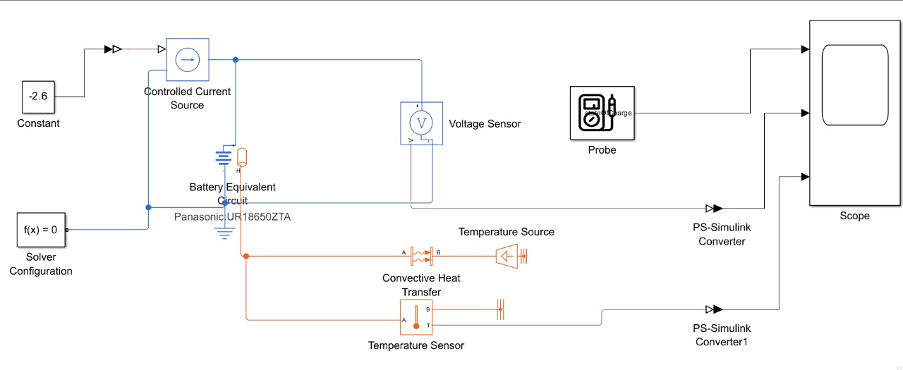

Fig 4.1 Simscape Simulation Model of Li-ion Battery

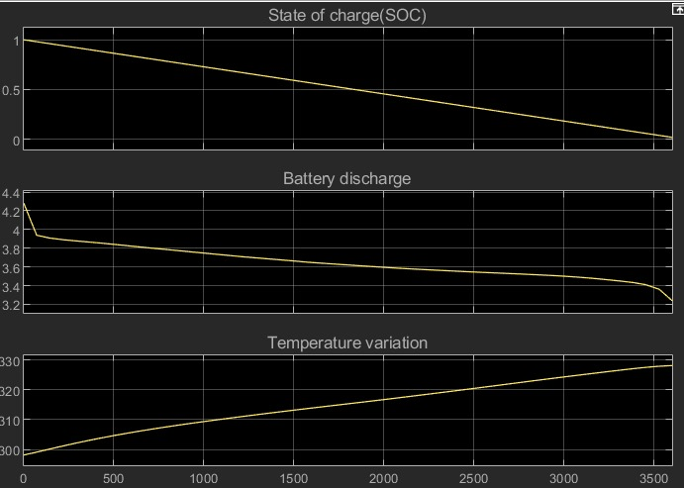

Fig 4.2 Simulation Results of Li-ion Battery

**4.3.2 Model Overview:**

The MATLAB model simulates the performance of a lithium-ion battery under discharge conditions, including its state of charge (SOC), voltage response, and thermal behaviour. Key components:

* The Panasonic UR18650ZTA lithium-ion cell is modelled with its electrical and thermal characteristics. This includes parameters such as initial capacity, nominal voltage, and thermal properties.
* The current source represents a constant discharge current of -2.6 A, simulating a load drawing power from the battery.
* Voltage Sensor monitors the terminal voltage of the battery during the discharge process.
* A thermal network (Convective Heat Transfer block and Temperature Source) simulates the heat generated during discharge and its dissipation through convection.
* The **Temperature Sensor** records the temperature variation over time.
* SOC, voltage, and temperature outputs are connected to a probe and visualized on the scope for analysis.

**4.3.3 Results Analysis:** SOC, Voltage, and Temperature Variations During Battery Discharge

State of Charge (SOC) Graph:

* The SOC decreases linearly with time as the battery discharges.
* SOC starts at 100% (fully charged) and drops to 0%, indicating complete discharge.

Battery Voltage Graph:

* The voltage drops gradually, with a noticeable initial decline followed by a slower decrease over time.
* The voltage decreases from 4.4 V (fully charged) to around 3.2 V (fully discharged).

Temperature Variation Graph:

* The temperature rises steadily throughout the discharge process.
* The temperature starts around 300 K and rises above 320 K.

**4.3.4 Simulation 2: Lead Acid Battery**

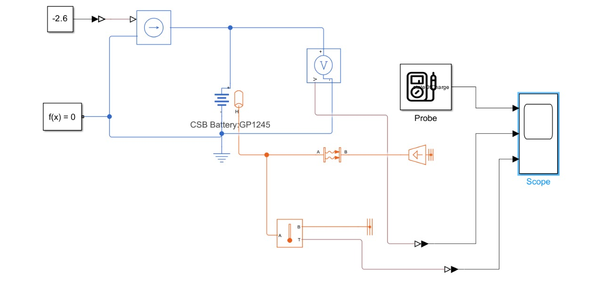

Fig 4.3 Simscape Simulation Model of Lead Acid Battery

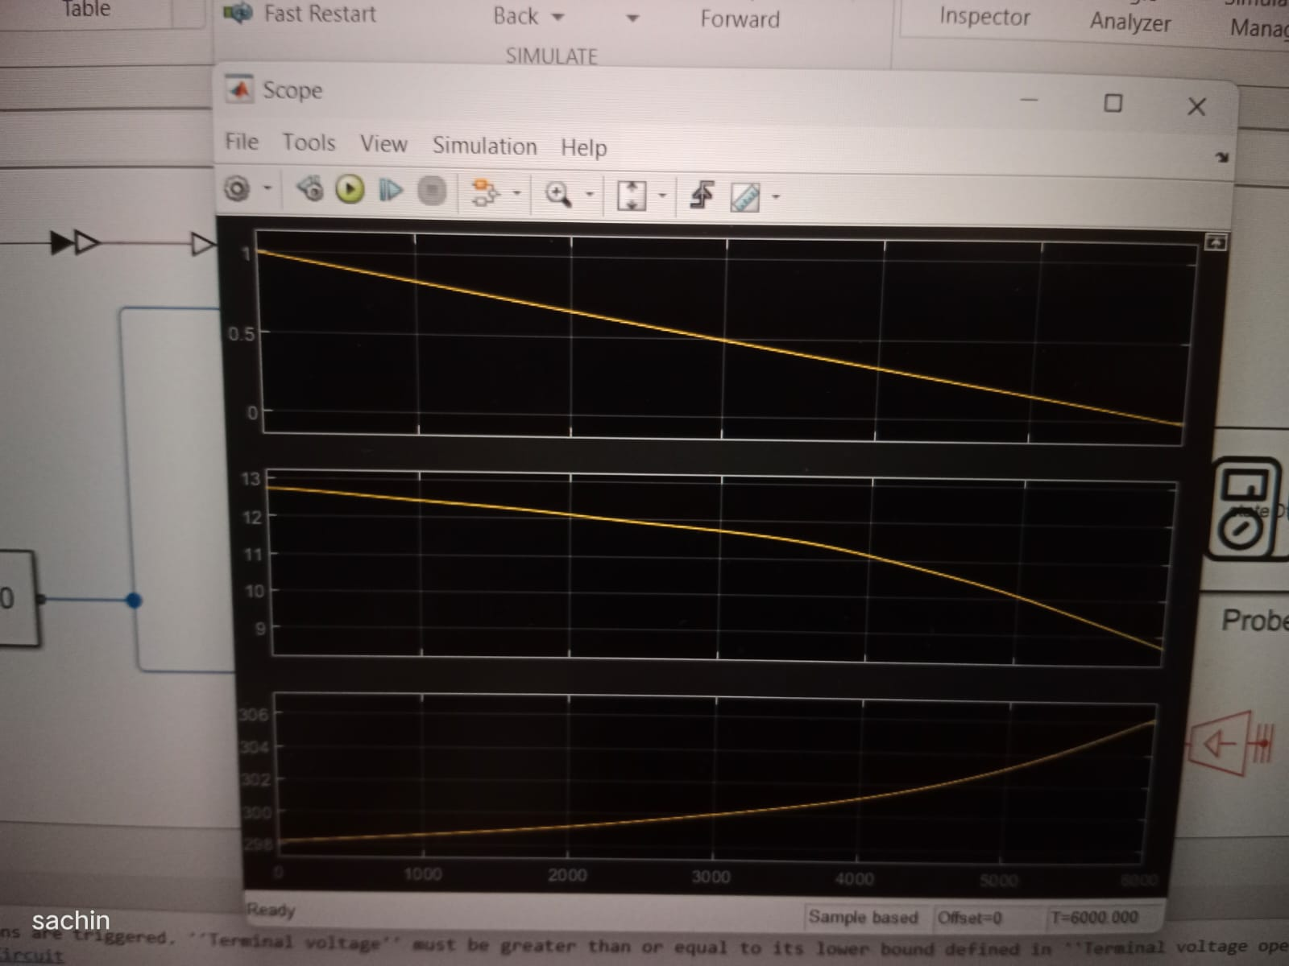

Fig 4.4 Simulation Results of Lead Acid Battery

**4.3.5 Model Overview**

The MATLAB Simulink model simulates the discharge behavior of a lead-acid battery, including its state of charge (SOC), voltage response, and thermal performance. The CSB GP1245 lead-acid battery is modeled with parameters such as initial capacity, nominal voltage, and thermal characteristics.

* Represents a constant discharge current of -2.6 A, simulating a load.
* Tracks the terminal voltage during the discharge process.
* Includes components like a convective heat transfer block and a thermal source to simulate heat generation and dissipation.
* A Temperature Sensor records temperature variations over time.
* SOC, Voltage, and Temperature Outputs are connected to a scope for visualization.

**4.3.6 Simulation Results**

The results are visualized as three graphs:

State of Charge (SOC) Graph:

* The SOC decreases linearly over time as the battery discharges.
* SOC starts at 100% (fully charged) and drops to 0% (fully discharged).

Battery Voltage Graph:

* The voltage decreases gradually, with a sharper decline at the beginning and end of the discharge.
* The voltage starts around 13 V (fully charged) and reduces to below 10 V (fully discharged).

Temperature Variation Graph:

* The temperature increases steadily during discharge. Temperature also rises but at a slower rate than lithium-ion, indicating less thermal sensitivity.

**4.3.7 Simulation 3: Nickel Metal Hydride Battery**

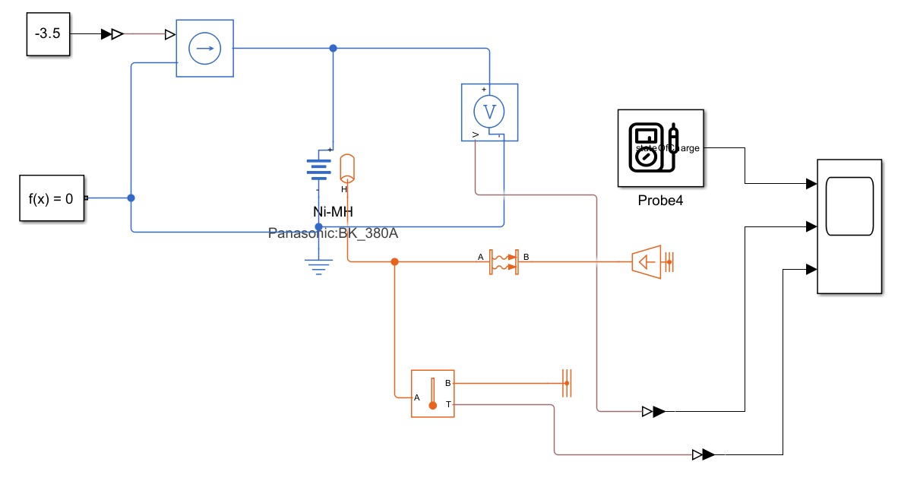

Fig 4.5 Simscape Simulation Model of Nickel Metal Hydride Battery

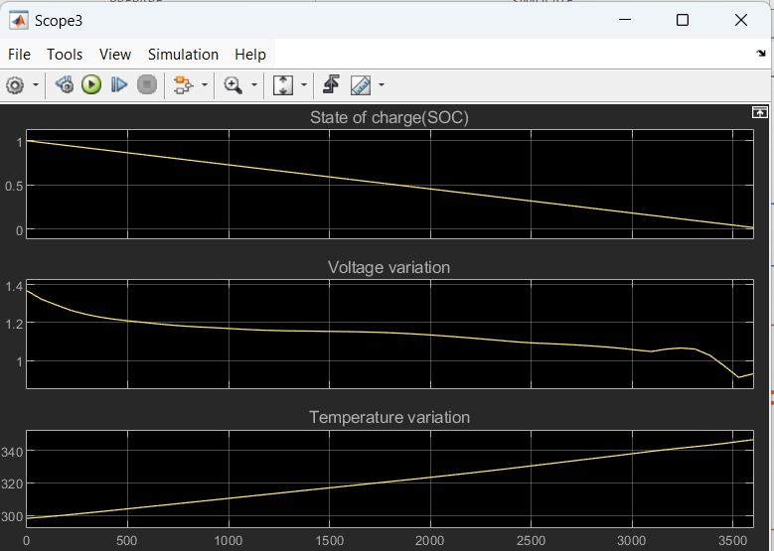

Fig 4.6 Simulation Results of Nickel Metal Hydride Battery

**4.3.8 Model Overview**

The model demonstrates the behavior of a Nickel-Metal Hydride (Ni-MH) battery during discharge under load conditions. The key components of the simulation include:

* Ni-MH Battery Block: Represents a Panasonic BK-380A Ni-MH battery, simulating its voltage, state of charge (SOC), and temperature variations over time.
* Load and Current Control: A current source applies a controlled load, discharging the battery.
* Measurement Probes: Used to measure the SOC, voltage, and temperature of the battery in real-time.
* Scopes: Display the dynamic behavior of the battery parameters during the simulation.

**4.3.9 Simulation Results**

State of Charge (SOC):

* The SOC decreases linearly over time as the battery discharges.
* The decline rate depends on the load applied and the battery capacity.
* A complete discharge is represented by the SOC approaching zero.

Voltage Variation:

* The voltage starts at a peak value (around 1.4V) and decreases gradually as the battery discharges. A slight dip in voltage occurs initially due to internal resistance and load conditions.
* Towards the end of the discharge cycle, the voltage drops more steeply, indicating the battery nearing full discharge.

Temperature Variation:

* The temperature rises steadily as the battery discharges, due to internal resistance and energy losses as heat.
* The rate of temperature increase is influenced by the current draw and the thermal properties of the battery.

**4.3.10 Simulation 4: Hybrid Battery Model with/without auxiliary Load**

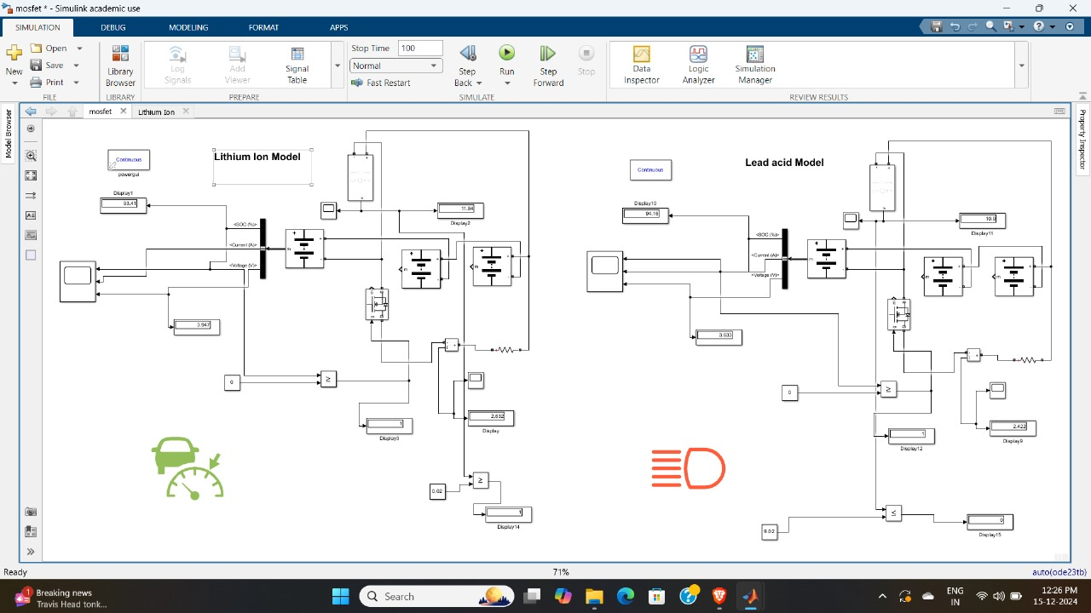

Fig 4.7 Simscape Simulation Model of Hybrid Battery System without Auxiliary Load

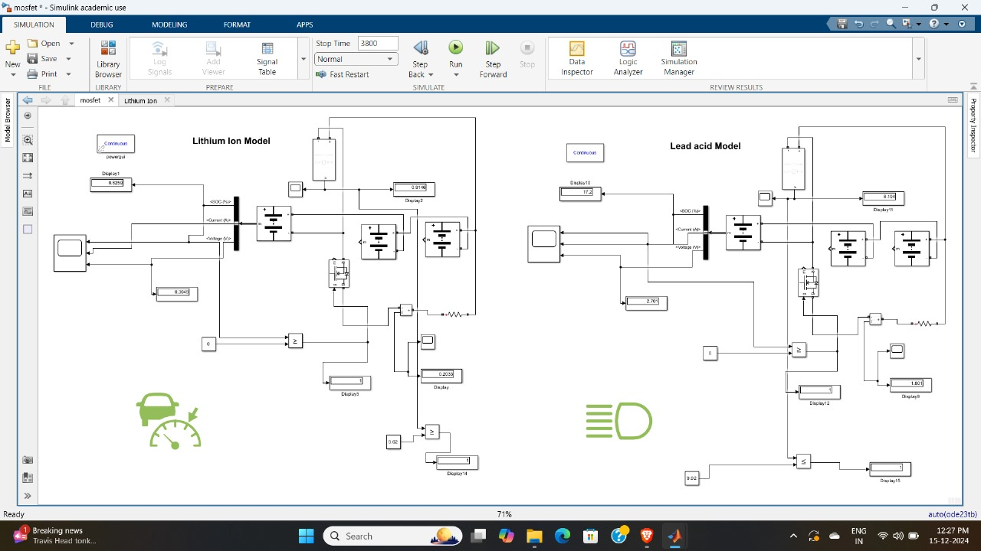

Fig 4.8 Simscape Simulation Model of Hybrid Battery System with Auxiliary Load

**4.3.11 Model Overview**

In the hybrid battery model for electric vehicles, a combination of lithium-ion and lead-acid batteries is used to address the varying power requirements of the system. The lithium-ion battery serves as the primary energy source for motor drive applications, whereas the lead-acid battery is reserved for auxiliary functions such as lighting, dashboard applications and smaller loads.

**Hybrid Model with Auxiliary Load**

* The first simulation incorporates both lithium-ion and lead-acid batteries connected to their respective loads.
* Lithium-Ion Battery: Supplies power to the main motor, responsible for vehicle propulsion. The simulation tracks key parameters such as State of Charge (SOC), voltage, and current drawn by the motor.
* Lead-Acid Battery: Connected to auxiliary loads, which include lighting and other minor electrical applications. This battery ensures that auxiliary loads do not burden the main lithium-ion battery.
* Power Management System: Controls the distribution of power between the batteries and their respective loads, ensuring efficient utilization and preventing overloading.
* Displays: The SOC, current, and voltage of both batteries are monitored through display blocks, allowing for real-time tracking of battery performance.

**Hybrid Model without Auxiliary Load**

* In this simulation, the lead-acid battery is disconnected from auxiliary loads, and only the lithium-ion battery is active, supplying power to the motor.
* This setup allows for the comparison of system efficiency and battery performance when auxiliary loads are excluded.
* The reduced load on the lithium-ion battery demonstrates improved energy efficiency, as evident from the extended SOC and lower current demand.

Auxiliary Load Detection:

* The system monitors the state of auxiliary loads (e.g., lights, dashboard systems). This is typically achieved by sensing the voltage or current demand from the auxiliary circuit.
* A threshold condition is defined in the control logic. For example:
  + If the auxiliary load demand exceeds a preset value, the lead-acid battery is switched on.
  + When the auxiliary demand drops below the threshold, the battery is switched off to conserve energy.

# **CHAPTER 5 RESULTS AND DISCUSSION**

The hybrid battery system simulation yielded valuable insights into the behavior and performance of a lithium-ion and lead-acid battery combination for electric vehicles. The results validated the effectiveness of this hybrid configuration in addressing diverse power demands, ensuring reliable operation, and enhancing energy efficiency.

**5.1 Results**

1. Performance of Lithium-Ion Battery

* The lithium-ion battery, designated for the main motor driving, demonstrated stable operation across varying load conditions.
* State of Charge (SOC):
  + The SOC depletion rate was consistent with the power drawn by the motor, showcasing the lithium-ion battery's ability to deliver high energy density for propulsion.
  + Under no auxiliary load conditions, the lithium-ion battery showed extended endurance, confirming its efficiency when used exclusively for motor applications.
* Voltage and Current Characteristics:
  + The voltage profile remained stable, with only minor fluctuations under dynamic motor load conditions.
  + The current drawn aligned with the expected power requirements of the motor, indicating efficient energy utilization.

2. Performance of Lead-Acid Battery

* The lead-acid battery efficiently handled auxiliary loads such as lighting and other smaller electrical components in the system.
* Switching Operation:
  + The power management system seamlessly switched the lead-acid battery ON/OFF for auxiliary applications based on demand. This ensured the lithium-ion battery was not burdened with non-propulsion tasks.
* State of Charge (SOC):
  + The SOC of the lead-acid battery decreased at a slower rate due to its limited use for auxiliary functions, ensuring longevity and minimizing the risk of over-discharge.
* Voltage Regulation:
  + The DC-DC converter maintained a consistent voltage output for the auxiliary loads, enhancing reliability.

3. Hybrid System Efficiency

* The combination of lithium-ion and lead-acid batteries allowed for efficient load distribution:
  + The lithium-ion battery focused on high-power demands (motor drive).
  + The lead-acid battery handled auxiliary loads, ensuring that the main propulsion system's performance remained unaffected.
* With Auxiliary Load:
  + The presence of auxiliary loads slightly increased the overall energy consumption, but the hybrid system managed the distribution effectively.
  + The lithium-ion battery's SOC decreased faster compared to the no-load condition, but within acceptable limits.
* Without Auxiliary Load:
  + The lithium-ion battery exhibited improved endurance, demonstrating the benefits of load segregation.

4. Simulation Validation

* The MATLAB/Simulink models provided accurate representations of the hybrid system's real-world behavior, with results aligning with theoretical expectations.
* The ability to monitor SOC, voltage, and current in real-time provided crucial data for performance analysis and optimization.

**5.2. Discussions**

The hybrid battery system's development and simulation highlight the potential for combining lithium-ion and lead-acid batteries in electric vehicle (EV) applications. The discussion below evaluates the results, their implications, and the broader relevance of this work:

1. Rationale for a Hybrid Battery System

* Electric vehicles require a power system that can address both high energy demands for propulsion and lower power requirements for auxiliary functions.
* The lithium-ion battery is well-suited for propulsion due to its high energy density, fast charge/discharge capability, and efficiency. However, it is relatively expensive and can be prone to faster degradation under mixed loads.
* The lead-acid battery is a cost-effective alternative for auxiliary applications, offering robustness and reliability for tasks like lighting, infotainment systems, and climate control.
* Combining these two batteries creates a balanced system that leverages their respective strengths while minimizing limitations.

2. Performance Analysis

* The results confirmed the lithium-ion battery's ability to handle high-current loads, maintaining a stable voltage profile for motor operation. This stability is crucial for providing consistent driving performance in real-world EVs.
* The lead-acid battery’s integration for auxiliary loads proved efficient, as it reduced the burden on the lithium-ion battery. This segregation of roles extends the lifespan of the lithium-ion battery by preventing unnecessary cycling for low-power functions.
* The hybrid system ensures better utilization of both batteries, creating a power architecture that is both cost-effective and efficient.

**3.** Advantages of Load Segregation

* By designating the lithium-ion battery exclusively for propulsion, its depth of discharge (DoD) remains controlled, reducing the risk of accelerated degradation.
* The auxiliary loads, which are generally intermittent and lower in power, do not significantly impact the SOC of the lead-acid battery, enhancing its reliability for extended periods.
* The seamless switching between batteries ensures uninterrupted operation of auxiliary systems, providing a user-friendly experience.

4. Impact of Auxiliary Load

* The simulation revealed that auxiliary loads slightly increased the overall energy consumption of the system. However, this increase was mitigated by the efficient switching mechanism and voltage regulation provided by the DC-DC converter.
* With the auxiliary loads active, the lithium-ion battery's SOC depleted faster. This observation emphasizes the importance of optimizing auxiliary power consumption and improving the energy efficiency of low-power devices in EVs.

5. Scalability and Practical Implications

* The hybrid system's modularity allows for easy scalability. For instance:
  + Higher-capacity lithium-ion and lead-acid batteries can be used in larger EVs or buses.
  + Additional energy sources, like supercapacitors or solar panels, can be integrated for further optimization.
* In real-world EV designs, the hybrid approach can reduce manufacturing costs by minimizing the reliance on expensive lithium-ion batteries, while still ensuring sufficient power delivery for all applications.

**CHAPTER 6**

**CONCLUSION AND SCOPE FOR FUTURE WORK**

**6.1 Conclusion**

The hybrid battery system combining lithium-ion and lead-acid batteries successfully demonstrated a practical and efficient solution for electric vehicle (EV) applications. The lithium-ion battery was optimized for high-energy propulsion demands, while the lead-acid battery effectively powered auxiliary applications, ensuring load segregation and enhancing the overall energy efficiency of the system. The seamless switching mechanism between the two batteries maintained operational stability, reducing the burden on the lithium-ion battery and improving its lifespan. The simulation results validated the effectiveness of this configuration, confirming its suitability for cost-effective and sustainable EV designs. This project provides a foundational approach for hybrid battery systems, addressing key challenges in energy management and offering significant insights into their real-world applications.

**6.2 Scope for Future Work**

Future scope of the work involves:

* Dynamic Switching Mechanism: Incorporate advanced switching algorithms to dynamically manage power distribution between lithium-ion and lead-acid batteries based on real-time demands and system conditions.
* Battery Management System (BMS): Develop a BMS for efficient monitoring and control, including SOC tracking, thermal management, and protection features.
* Scalability and Testing: Scale the model for larger EVs and conduct hardware testing to validate and refine the design.

**Summary:**

This chapter describes the conclusions that were reached after a detailed and comprehensive study and experimentation. The future scope of the study has also been explained in brief.

**References:**

1. Experimental Investigations into a Hybrid Energy Storage System Using Directly Connected Lead-Acid and Li-Ion Batteries ,2024

<https://www.mdpi.com/1996-1073/17/18/4726>

1. Design and control of the hybrid lithium-ion/lead–acid batter by Sebastian Wodyk , Maciej Wieczorek , Paweł Witaszek , Rafał Poliszkiewicz ,2023

<https://www.sciencedirect.com/science/article/pii/S2352484723008405>

1. A Battery Management Strategy in a Lead-Acid and Lithium-Ion Hybrid Battery Energy Storage System for Conventional Transport Vehicles by Andre T. Puati Zau.,2022

<https://www.mdpi.com/1996-1073/15/7/2577>

1. Techno-economic analysis of lithium-ion and lead-acid batteries in stationary energy storage application by Abraham Alem Kebede , Thierry Coosemans , Maarten Messagie , Towfik Jemal , Henok Ayele Behabtu , Joeri Van Mierlo , Maitane Berecibar ,2021

<https://www.sciencedirect.com/science/article/pii/S1879729619301437>

1. A comparative study of lithium ion to lead acid batteries for use in UPS applications by [Ana-Irina Stan](https://www.researchgate.net/profile/Ana-Irina-Stan?_tp=eyJjb250ZXh0Ijp7ImZpcnN0UGFnZSI6InB1YmxpY2F0aW9uIiwicGFnZSI6InB1YmxpY2F0aW9uIn19) ,[Maciej Swierczynski](https://www.researchgate.net/scientific-contributions/Maciej-Swierczynski-55908851?_tp=eyJjb250ZXh0Ijp7ImZpcnN0UGFnZSI6InB1YmxpY2F0aW9uIiwicGFnZSI6InB1YmxpY2F0aW9uIn19),[Daniel-Ioan Stroe](https://www.researchgate.net/profile/Daniel-Ioan-Stroe),[Remus Teodorescu](https://www.researchgate.net/profile/Remus-Teodorescu?_tp=eyJjb250ZXh0Ijp7ImZpcnN0UGFnZSI6InB1YmxpY2F0aW9uIiwicGFnZSI6InB1YmxpY2F0aW9uIn19),2014

<https://ieeexplore.ieee.org/abstract/document/6972152>

1. Regeneration of Hybrid and Electric Vehicle Batteries: State-of-the-Art Review, Current Challenges, and Future Perspectives by Alfonso P. Ramallo-González,2024

<https://www.mdpi.com/2313-0105/10/3/101>

1. Performance and dynamic charge acceptance estimation of different Lithium-Ion batteries for electric and hybrid electric vehicles by [Mahesh Padmanabh](https://ieeexplore.ieee.org/author/37086365132),[Manoj Madhukar Desai](https://ieeexplore.ieee.org/author/37086364888) ,2017

<https://ieeexplore.ieee.org/abstract/document/8333894>